# SOLUTION ARCHITECTURE

**Design:**

* Even with the greatest ideas to overcome solutions for railway ticket gathering this time consuming process for checking the tickets generated.
* Even much resource available fraudulent may not be rectified
* This project provides the solution generating the QR code for tickets and verifies easily.
* In this project IOT device is connected and a python random code is generated and cloud services include(IBM Waston Platform, Node RED, WEB UI, Cloudant DB which stores the database of the applied tickets )
* All booking details of customer is stored in the cloud database with an unique ID and they can be retrieved back when the ticket collector scans the QR code.
* Finally architecture connects with user and Fast2SMS application to send message to user.
* A GPS module is present in the train to track.
* The live status of the train is uploaded in the web app continuously

# Software and system required:

* + Arduino IDE
  + Embedded C
  + 4GB processor and OS-Windows/Linux/MAC

# Block diagram:



User

Cloud Service

IOT DEVICE

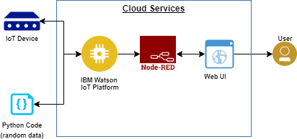

**IOT Device**

solenoid valve

IBM waston platform, Node RED, Web UI, Cloudant DB

ARDUINO***/***

ESP8266

**Cloud Service**



Cloud DB

IOT Devices

Web UI

IBM Watson

Node red